From the archive, 6 September 1968: Philip Larkin gets the blues
Philip Larkin reviews a new book on the byways of the blues
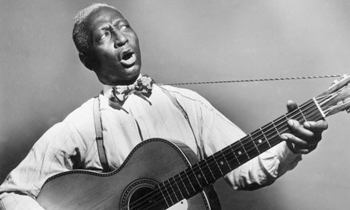
American blues musician Huddie 'Lead Belly' Ledbetter (1889 - 1949) playing a guitar and singing, circa 1935. Photograph: Hulton Archive/Getty Images
Screening the Blues, by Paul Oliver (Cassell, 42s).
"It is one of the strengths, but but also one of the weaknesses of the blues," writes Mr Oliver, "that - " well, to put it bluntly, that it attracts performers who can neither play nor sing. And, in fact, one does get heartily sick of the blues, at times: the whimpering and mumbling about "my baby done lef' me," the kindergarten smut, the outmoded properties ("Please, Mr Fireman"), and above all the relentless lack of originality; for thirty or forty years we have had to endure these same icemen and riders and back doors and evening suns going down.
Mr Oliver admits this: as he says, the "stockpile of traditional phrases" serves as "an indispensable substitute for original thought." The blues has nothing of the calypso's vitality; "national events and successes are seldom recorded; political comment is to be found on a handful of blues, Jim Crow laws and poll taxes hardly at all. Of the Civil Rights movement, of freedom marches, of anti segregation demonstrations and lunch-counter sit-ins, Black Muslims and Black Power, the blues says nothing." Not even about lynching.
Nevertheless, the music has its devotees, and Mr Oliver is one of them. The present book reads rather like a lengthy footnote to his earlier book "Blues Fell This Morning," published in 1960; this was a moving tessellation of blues lyrics and exegetical comment arranged to show what the main themes of the blues were - work, railroads, love, and so on. "Screening the Blues" takes up half a dozen minor blues themes, Christmas, preaching and preachers, the numbers game, Joe Louis, and obscenity; illustrating them in much the same way from historical records.
These are interesting enough, though to say that Negroes regard Christmas as a week-long debauch or that they suspect preachers of having an eye for drink and women is hardly to demonstrate that their society is utterly alien to ours.
Probably the final section, "The Blue Blues," will earn the book its keep: Mr Oliver has taken advantage of the present permissive climate in publishing to include a study nearly a hundred pages long of "obscene" blues songs. These range from the innumerable metaphors ("Phonograph Blues" - "my needle point got rusty," etc.) to much more outspoken conventions, such as "Shave 'Em Dry," and "The Dirty Dozens," an odd insult game wherein each player utters outrageous abuse of the other's family, until one or other can stand it no longer and the knives come out.
Although blues singers are much bolder than normal about sex, to the extent of calling themselves Steady Roll Johnson or Boodle-It Wiggins, most blues lyrics are heavily censored by the record company, and what gets past is usually impenetrable under a strong accent. Mr Oliver has dug out several where the language is improper, but in most cases it sounds as if the singer was trying to shock, rather than make the audience supply the obscenity mentally, as in the large majority of the songs. The suggestion is that obscenity is the release of social tension and so an agent of health. Certainly there is a wealth of material here that will come as a surprise to most blues followers.
The book, by the way, should really be read in conjunction with a record "Screening the Blues" (CBS 63288), which includes a number of the songs referred to, and which supplies the dimension of musical excitement as Mr Oliver's somewhat colourless prose never could.

