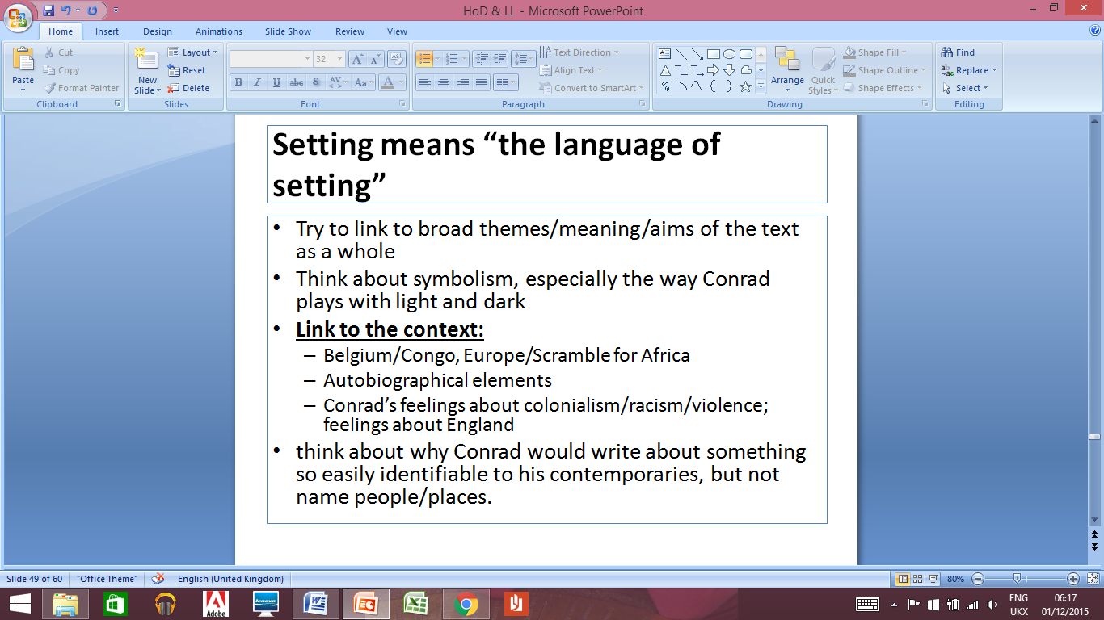

**Intradiegetic Setting: Marlow’s Story**

* None of the locations named – why?
* Description of the European city?

**Setting: Time**

* When is the story told?
* What is the time frame for the telling of Marlow’s story?
* Significance of this?

**Diegetic Setting: Place (beginning & end)**

* London
* Thames
* Gravesend
* All named/located: significance?