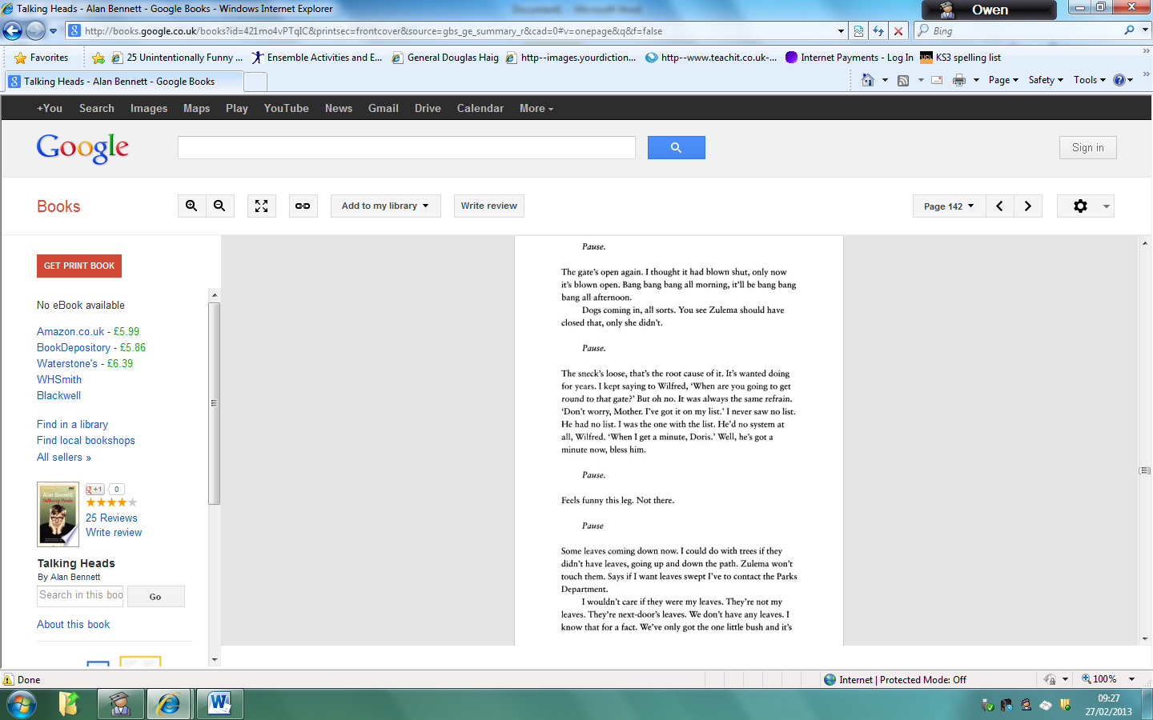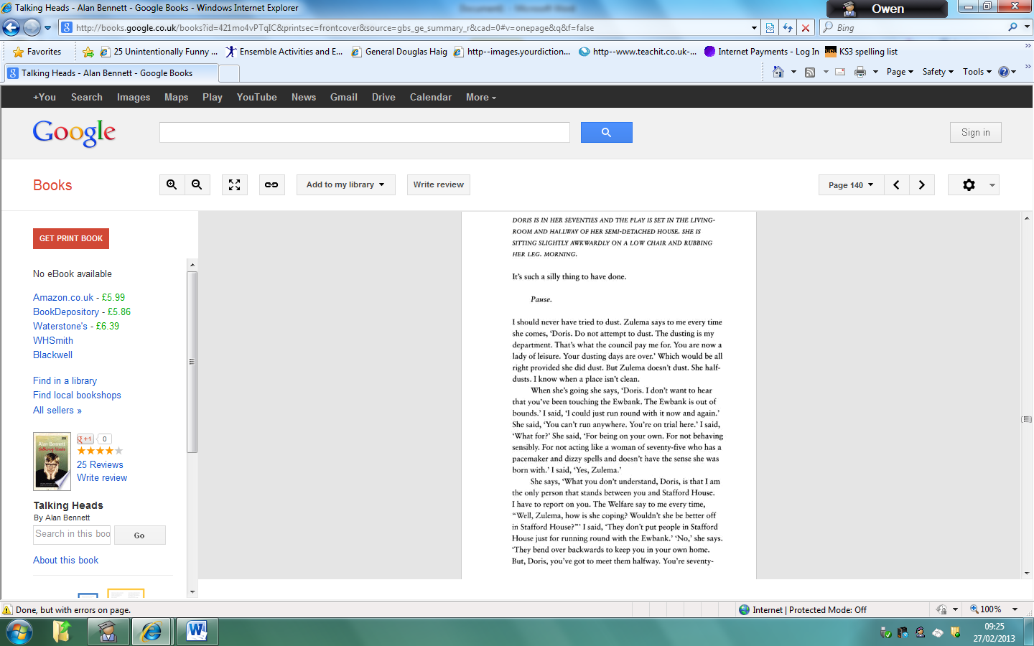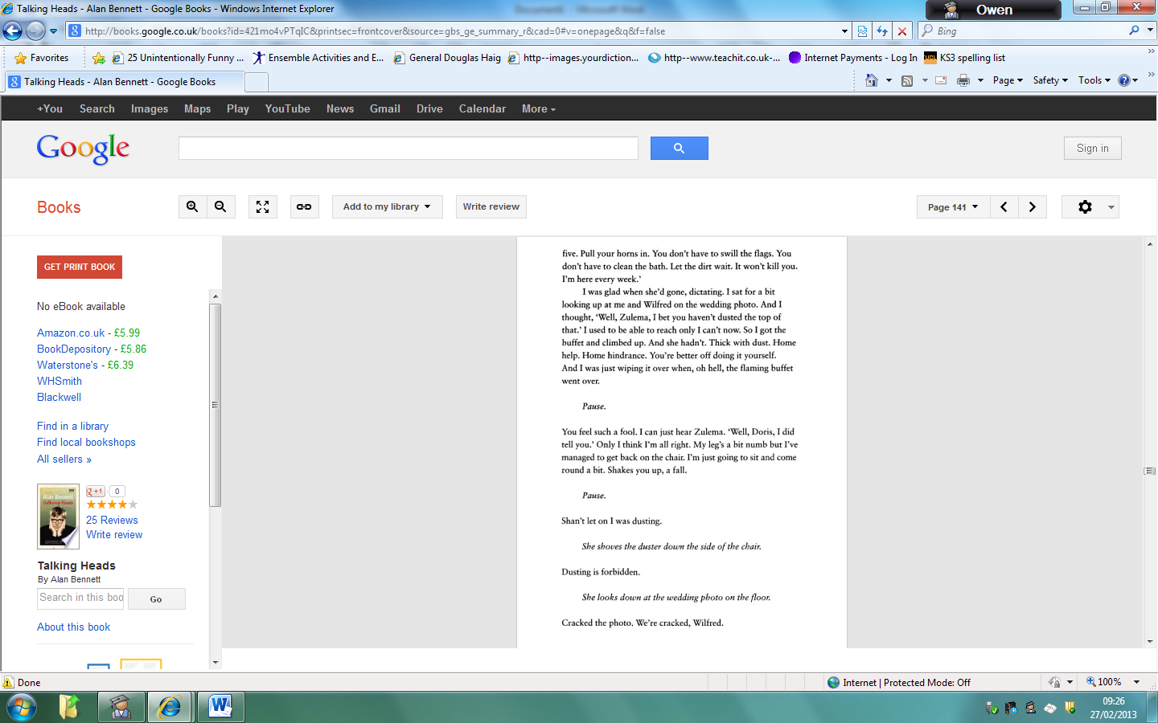

**Opening pages of “A Cream Cracker Under the Settee,” from *Talking Heads* by Alan Bennett (1988)**